**Synopsis Report**

**on**

**Hexapod Spider Robot**

***Submitted in partial fulfilment of the***

***Requirements for the award of the degree***

***of***

BACHELORS OF ENGINEERING

in

MECHATRONICS ENGINEERING

**Submitted By: - Faculty Supervisor: -**

Jasmeet Singh Mr. Inderpreet Singh  
19BEM1018



**UNIVERSITY INSTITUTE OF ENGINEERING**

**CHANDIGARH UNIVERSITY**

**GHARUAN, MOHALI, PUNJAB, INDIA-140413**

**2019**

|  |  |  |
| --- | --- | --- |
| **INDEX** | | |
| **Sr. No** | **Content** | **Pg. No** |
| **1** | **CANDIDATE’S DECLARATION** | **2** |
| **2** | **INTRODUCTION** | **3** |
| **3** | **LITERATURE REVIEW** | **3** |
| **4** | **METHODOLOGY**   * **OBJECTIVE** * **STEPS INVOLVED** | **4 – 5** |
| **5** | **BLOCK DIAGRAM** | **5** |
| **6** | **REQUIRED ELEMENTS & DESCRIPTION OF PARTS** | **6 – 7** |
| **7** | **Approximate Cost and Total Cost** | **8** |
| **8** | **WORK PLAN** | **8 – 9** |
| **9** | **ACKNOWLEDGEMENT** | **10** |
| **10** | **REFERENCE** | **10** |

|  |  |  |
| --- | --- | --- |
|  |  |  |
|  |  |  |
|  |  |  |
|  |  |  |

**CHANDIGARH UNIVERSITY, GHARUAN, MOHALI**

**CANDIDATE'S DECLARATION**

I “Jasmeet Singh'' hereby declare that the work embodied in this synopsis entitled **“**HEXAPOD SPIDER ROBOT**”** is in partial fulfilment of requirements for the award of the degree of B.E (MECHATRONICS ENGINEERING) at **CHANDIGARH UNIVERSITY GHARUAN, MOHALI.** The work which is being presented in this synopsis submitted to the **Department of Mechatronics Engineering** is an authentic record of a bonafide piece of work.

Signature

(Jasmeet Singh)

Supervisor Signature

(Name and Designation)

**INTRODUCTION**

Robots can be found all over. One of the most significant piece of a robot is its skeleton. There are a few essential suspension types: wheeled, followed and legged chassises. Wheeled chassises are quick, yet not appropriate for unpleasant landscape. Followed chassises are more slow, however more reasonable to rough landscape. Legged chassises are very lethargic and more hard to control, yet incredibly vigorous in harsh landscape. Legged chassises are fit to cross enormous openings and can work even in the wake of losing a leg. Many investigates were acted in this field in beyond couple of years, due to its enormous potential. Legged chassises are particularly great for space missions. There are likewise a few activities in military research. I expect to make a modest legged stage, which would permit examination and testing of strolling chassises. Make a framework with numerous sensors that permits the undercarriage any development or conduct. The robot ought to be driven from remotely associated PC and ought to send all accessible information from sensors, which will be shown on the PC in the UI program. This stage ought to be widespread, anybody could interface with the robot and drive it and anybody may associate and send his own information to the UI program of the control PC.

**LITERATURE REVIEW:**

There are a few organizations, which are delivering hexapod robot models. Name Lynxmotion or Trossen Robotics. The two organizations offer an assortment of leisure activity and exploration level robot packs and parts. They additionally offer a few kinds of hexapods. These Hexapod. This robot was planned and built during the task. It is furnished with sonars, camera, LCD show and more frill. robots contrast in the body shape and leg development. All robots accompany programming, which gives control of servomotors utilizing backwards kinematics and making custom steps. Robot units are sold for about $ 1,000, contingent upon the variant. Albeit a few arrangements as of now exist and have extraordinary potential, every last one of them has some weakness. The first is value, which is very high, about $ 1,000 a piece. One more burden is gear of

the robots. The majority of the accessible robots have restricted development choices, such as missing foot sensors, which are hard to introduce later, or servomotor type with inadequate power or elements. Likewise, the batteries are frequently underlying the body and it is troublesome or even inconceivable to eliminate them. As a result of these weaknesses, we chose to fabricate a robot of our own.

**METHODOLOGY**

**Objective:**

This new robot is prepared to do similar developments like business renditions and attempts to eliminate their negatives. Robot is made of plastic profiles via 3d designing the whole model due to their simple accessibility and adequate design we are able to operate the robot very preciously. This robot is mainly designed for military purpose uses this robot can go to different trains where many other vehicles and humans can't go, to reduce the number of casualties military persons they can send this robot first to scout the area and potentially finding the information they are looking for the same goes for any other organization that want to use it in remote areas due to its spider type design it can easily make his way through main difficult paths where normal wheel robots can't go. In contrast to business forms, this hexapod has likewise a wide assortment of sensors and equipment, Infrared sensor, LCD show, encoders. All the data from the sensors are shipped off the PC and showed in the UI program. It is additionally conceivable to utilize a library, which permits perusing of the multitude of information from the robot and sending orders to it. This robot can walk utilizing stand, wave or ripple step and is additionally fit for turn. Every leg is outfitted with a power touchy servomotor to determine joint's present position. IR can recognize impediments to keep away from impacts.

**Steps Involved algorithm**

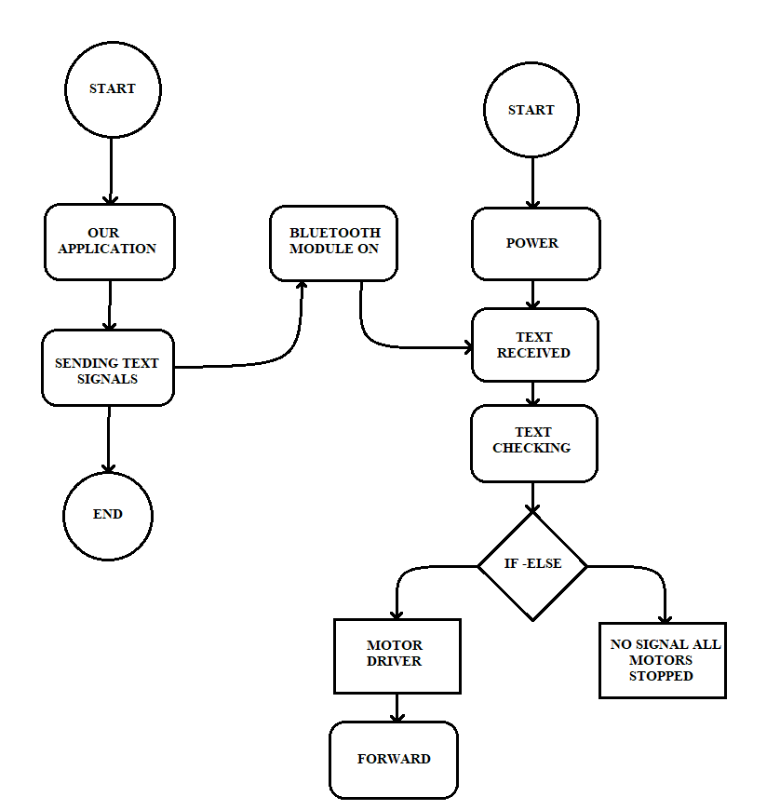

Block Diagram

### SYSTEM DESIGN

#### *A. Mechanical design*

These pictures shows the structure of the robot. A few arrangements of strolling robots and most normal strolling steps are portrayed. There are numerous ways how to order strolling robots by a body shape, number of legs, number of levels of opportunity per leg or velocity method. Different choices can be consolidated to accomplish a wide range of arrangements. No less than two levels of opportunity are expected to develop a mobile robot the first for lifting the leg, second for turning it. By and by there ought to be three levels of opportunity for a decent working chassis, on the grounds that the legs move along a circle and the forward development of the body causes slipping between the foot and the landscape, which can be remunerated by third joint.

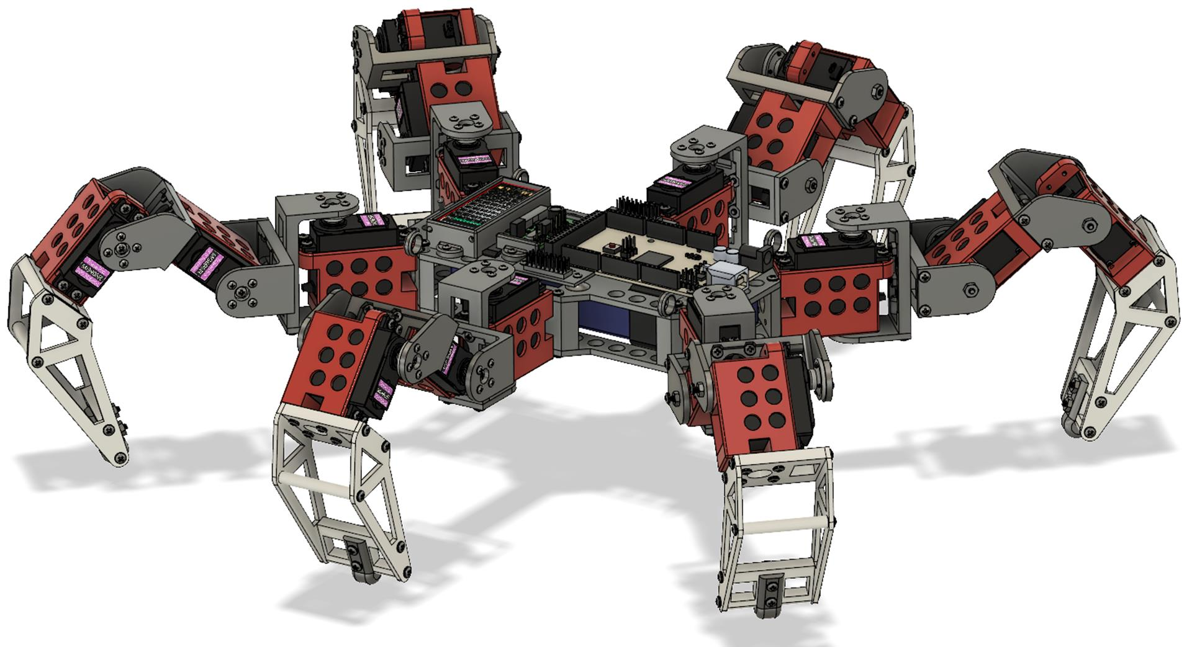

**DESCRIPTION OF PARTS:**

1. **Arduino:** We used Arduino Mega for this robot to control all the servo motors individually. The Arduino Mega board is based on the ATmega2560 microcontroller.
2. **Shields:** We used 2 Shield boards to manage the high number of servo motors. That also helps to provide a different power source to the motors.
3. **Power distribution module:** Due to high number of servo motors we used a power distribution module.
4. **Motors:** We used MG996R 180° servo motors as they are perfect for this robot. We used 18 servo motors in total 3 for each leg.
5. **Lithium-Polymer Battery:** We used a lithium-polymer battery to power the robot. It was a 2C battery that provides 7.4 V and 2.2 AH of current.
6. **Bluetooth module:** Bluetooth module is utilized for correspondence among robot and regulator. It gives remote sequential correspondence. It is additionally utilized for ace slave correspondence.
7. **CONNECTING WIRES:** Wires are a vital piece of each framework and they are utilized for electrical connections between different electronic parts.

**Approximate Cost of project:**

Arduino Mega 1000

Shield 2 X 400 = 800

Power Module 150

MG996R Servo Motors 18 X 250 = 4500

3D Printing 5000

Battery 600

Bluetooth Module 250

Wires 100

**TOTAL COST Rs.12400**

**Work plan and work distribution:**

Pankaj Kumar:

* Coding
* Program Development
* Idea generation
* Feature enhancement
* Physical assembly
* PPT formation
* Research Paper

Shivesh Pandey:

* OS Design
* Application Development
* Idea generation
* Feature enhancement
* Physical assembly
* PPT formation
* Research Paper

Jasmeet Singh:

* 3D Modeling
* Design & Build
* Soldering
* Idea generation
* Feature enhancement
* Project Report
* Project Synopsis
* PPT modification
* Research Paper

Mukul Kumar:

* Kinematics Calculations
* Name generation
* Feature enhancement
* Project Report
* Project Synopsis
* PPT modification

Harshul Aggarwal:

* Idea generation
* Name generation
* Design & Build
* Feature enhancement
* Physical assembly
* PPT modification

**FUTURE SCOPE and modifications possible:**

Obviously, the entire world has confronted the Coronavirus circumstance. So it required some investment for us to meet and give the project its last touch. Some colleagues who are close by the college attempted to do the work on the actual model and others collaborated through web-based mode. Due to the Coronavirus circumstance, in the future we can add different sensors that will help to measure various things that can eventually help the robot to be more accurate and precise, and we can also implement a camera that will provide vision and information to the operator.

**ACKNOWLEDGEMENT**

It gives us proud privilege to complete this project work. This is the only page where I have the opportunity to express my emotions and gratitude from the core of my heart.

It gives us great pleasure in expressing sincere and deep gratitude towards my guide Mr Inderpreet Singh for his valuable and firm suggestions, guidance and constant support throughout the completion of project named “Hexapod Spider Robot”. I am thankful to Chandigarh University for providing me various resources infrastructure facilities.

I also offer my most sincere thanks to my team members and staff members of Mechatronics Department, University Institute of Engineering, Chandigarh University for cooperation provided by them in many ways.

9th December, 2021 Jasmeet Singh

**REFERENCES:**

[1] Uluc Saranlı. Dynamic locomotion with a hexapod robot. PhD thesis, The University of Michigan, 2002.

[2] NASA. All-terrain hex-limbed extra-terrestrial explorer. http://athlete.jpl.nasa.gov/, 2009.

[3] Franco Tedeschi and Giuseppe Carbone. Designissues for hexapod walking robots. Robotics, 3(2):181–206, 2014.

[4] Boston Dynamics. Boston dynamics: Dedicated to the science and art of how things move.http://www.bostondynamics.com/robot petman.html, 2015.

[5] Boston Dynamics. Boston dynamics: Dedicatedto the science and art of how things move.http://www.bostondynamics.com/robot bigdog.html, 2015.

[6] Boston Dynamics. Boston dynamics: Dedicatedto the science and art of how things move.http://www.bostondynamics.com/robot ls3.html, 2015.